# Statistical Analysis of NBA Betting trends

With an abundance of data to analyze from a statistical point of view, there were quite a few findings to explore, as well as more questions raised. What this report contains is a statistical analysis of Vegas’ predictions, actual results, trends, what this information could be used for and potential questions.

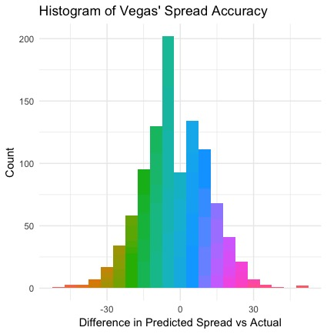Starting from the basics, I determined the range, and mean of Vegas’ predicted spread for the home team in each game. The respectful values are [-19:14] and -2.59 in favor of the home team. This gives a foundation for expected game scores and what home court advantage could mean in the eyes of Vegas. This means that on average throughout the NBA season, Vegas predicted that the home team would win by 2.59 points on average.

Taking a look at averages for actual spread, predicted spread, and the differences in results breaks down as follows. The average actual spread for the home team for this dataset is -2.12. The average predicted spread for the home team by Vegas in this dataset is -2.59. This difference of -.47 in favor of the home team may give some insight that Vegas values home court advantage by .47 points more than what actually may be.

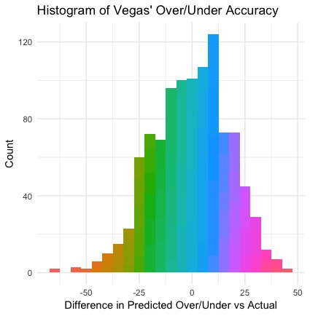

Exploring the over/under trends and Vegas accuracy provided surprising results. The over/under of a game is calculating the total points that will be scored between both teams in a given situation. The average prediction by Vegas for over/under across all games observed is 212.19. The average over/under results for the same occurrences were 212.58. This is just a difference of .39 points on average. This difference gives insight that Vegas is typically predicting an over/under for a game by .39 points greater than the actual results.

Further exploration reveals more information on the amount of times betting the under vs. betting the over and what the results look like. Of the 1031 observed games, the over won 525 times, or 50.92%. Of the 1031 observed games, the under won 493 times, or 47.82%. There were 13 unique times where the over/under of the game was predicted exactly correct, or 1.26%.

There is large discrepancy in lower scoring games and predicted lower scoring games. Vegas predicted a total score of under 200 points on 82 separate occasions, or 7.95%. However, there were 273 occasions where the final score of the game ended below 200, or 26.48%.

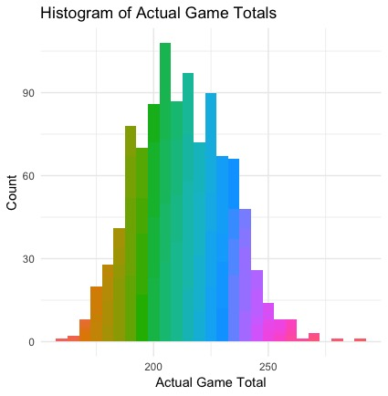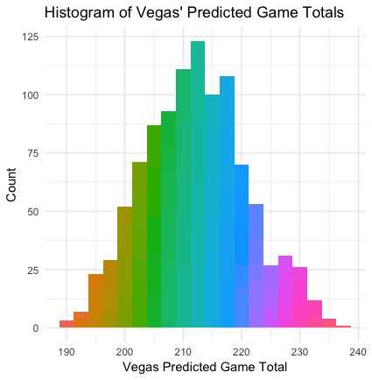

This continues to build on the trend that Vegas predicts higher scores than what actually occurs.

Something interesting to note, there were 17 times that the spread of the home team was -14 through -19. These 17 separate games were made up of just 4 teams on their home court. Golden State Warriors (8), Houston Rockets (7), Cleveland Cavaliers (1) and Toronto Raptors (1). Of the 17 times that these extremely large spreads were predicted, the home team only covered the spread 4 times. This means that on those few rare occasions of a large home spread, the home team only covers the spread 23.5% of the time.

There were 21 times where the home team were underdogs by 10 points or more. Of these 21 times, the home team covered the spread 9 times, resulting in a 42.86% coverage rate for the home team on extremely large spreads.

An interesting trend that was discovered is that Vegas tends to predict games as ending much closer than the actual result. Of the 1032 occurrences, Vegas predicted a spread between -2.5 and 2.5 for the home team 214 times, for 20.74%. The actual results revealed that the final home spread ended between -2.5 and 2.5 just 93 times, 9.01%.

Vegas was unable to decide on a favorite on 10 separate occasions, meaning that the spread was 0. This is just .97% of the time. Of these 10 games, the Away team won 7 out of the 10 times. What this could mean is that the home team is getting points just for being the home team and by a fair amount. The average home spread difference between the actual home spread result and the predicted spread amount by Vegas during these 10 occasions is 3.8 points.

Of all games that were examined in this analysis, there were 46 occasions where the game ended as a one-point game. This is 4.46% of the reviewed data.

There are few major takeaways from this statistical analysis. The first is that Vegas is very accurate with their predictions. On average, their prediction for NBA spread is only .47 points off from the actual results. The average predicted home spread of this dataset is -2.57 and the average actual home spread is -2.12. In regards to the over/under, the average predicted over/under from this dataset is 212.19 and the actual average over/under is 212.58. The difference in Vegas’ prediction is just .39 higher than the actual results.

What this leads to is identifying those instances where Vegas had their largest errors in predictions, as this could provide insight to best possible situations where gamblers could make their money.

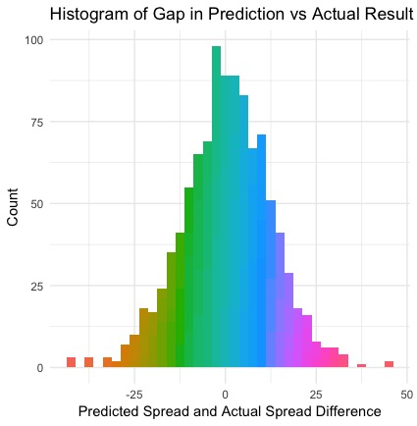

There were 420 occurrences where Vegas’ home spread prediction was off by 10 points or more. That accounts for 40.74% of all situations. Identifying these situations can help with identifying trends that may be there for a gambler to take advantage of.

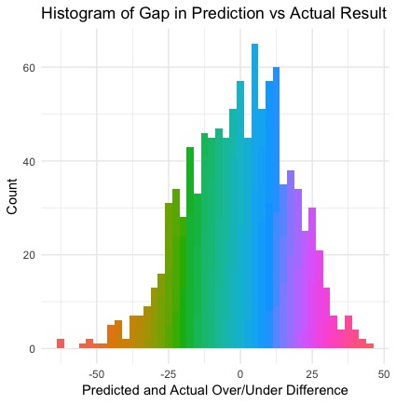

There were 429 situations where the difference in the Vegas predicted over/under was incorrect my 15 points or more. This accounts for 41.61%. The same can be said for the over/under opportunities as for the spread above. There are times where Vegas is very inaccurate in their predictions and identifying these situations will lead to identifying trends. The biggest question that comes from all of this analysis is how do we identify those trends from the results we can currently examine?